**FRONT END UI/UX MINI PROJECT**

Group Member Details:

Name and Roll Number : Angel Shiju [2462538] ,

Tenzin Choeying [2462534] ,

Sai Arjun N [2462528]

Email: [angel.shiju@btech.christuniversity.in , tenzin.choeying@btech.christuniversity.in](mailto:angel.shiju@btech.christuniversity.in%20,%20%20%20%20%20%20%20%20%20%20%20%20%20%20%20%20%20%20%20%20%20%20%20%20%20%20%20%20%20%20%20%20%20tenzin.choeying@btech.christuniversity.in) , [sai.arjun@btech.christuniversity.in](mailto:sai.arjun@btech.christuniversity.in)

Course: Front End UI/UX

Class : 3 BTCS IOT

Instructor Name: Dhiraj Alate

Institution: Christ University

Date of Submission: 11-08-2025

**Restaurant Landing Page**

Project Overview:

This project is a simple restaurant landing page created using HTML and CSS. It displays the restaurant name, navigation menu, hero section, menu list with prices, about us section, and contact details with an order form. The purpose is to provide an online presence for the canteen at Christ University.

Objectives:

- Design a single-page restaurant landing page using HTML and CSS.

- Include sections for menu items, about information, and contact details.

- Apply basic styling for an attractive and easy-to-read layout.

- Make the page simple and functional for students.

Expected Outcomes:

- A fully functional static restaurant landing page.

- Ability for visitors to view the menu and contact details easily.

- Practical experience in HTML structure and CSS styling.

Design Sections:

1. Header with restaurant name and navigation links.

2. Hero section with welcome text.

3. Menu section listing dishes with prices.

4. About Us section.

5. Contact Us section with address, phone, and order form.

6. Footer with copyright text.

Code snippets

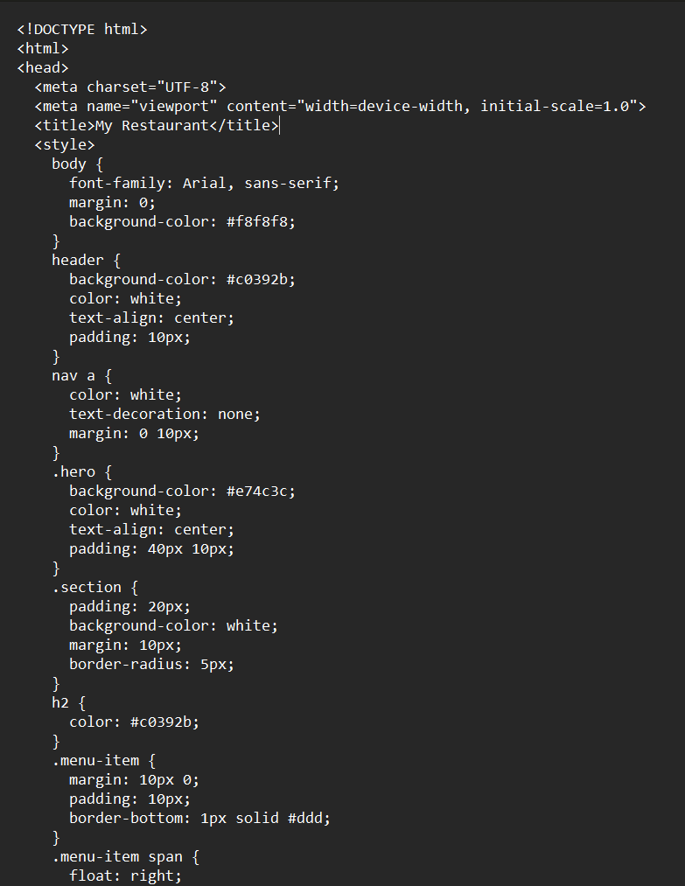

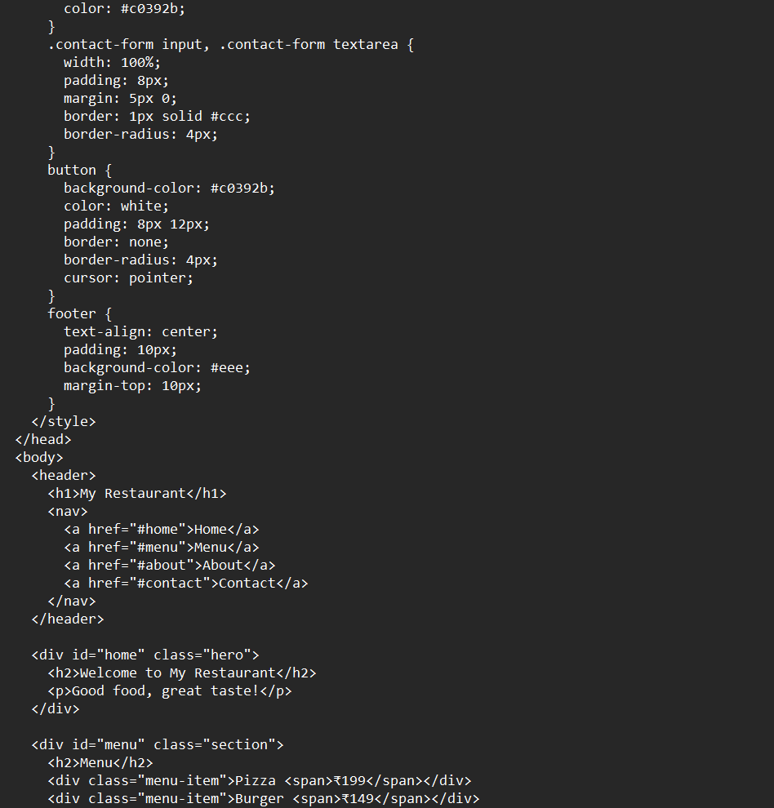

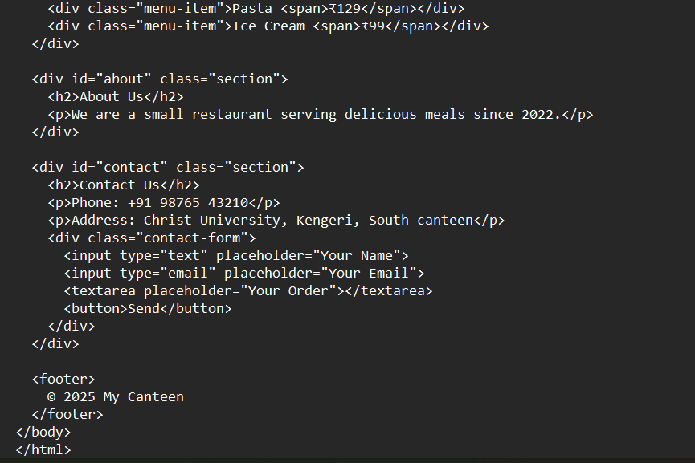

Code Output

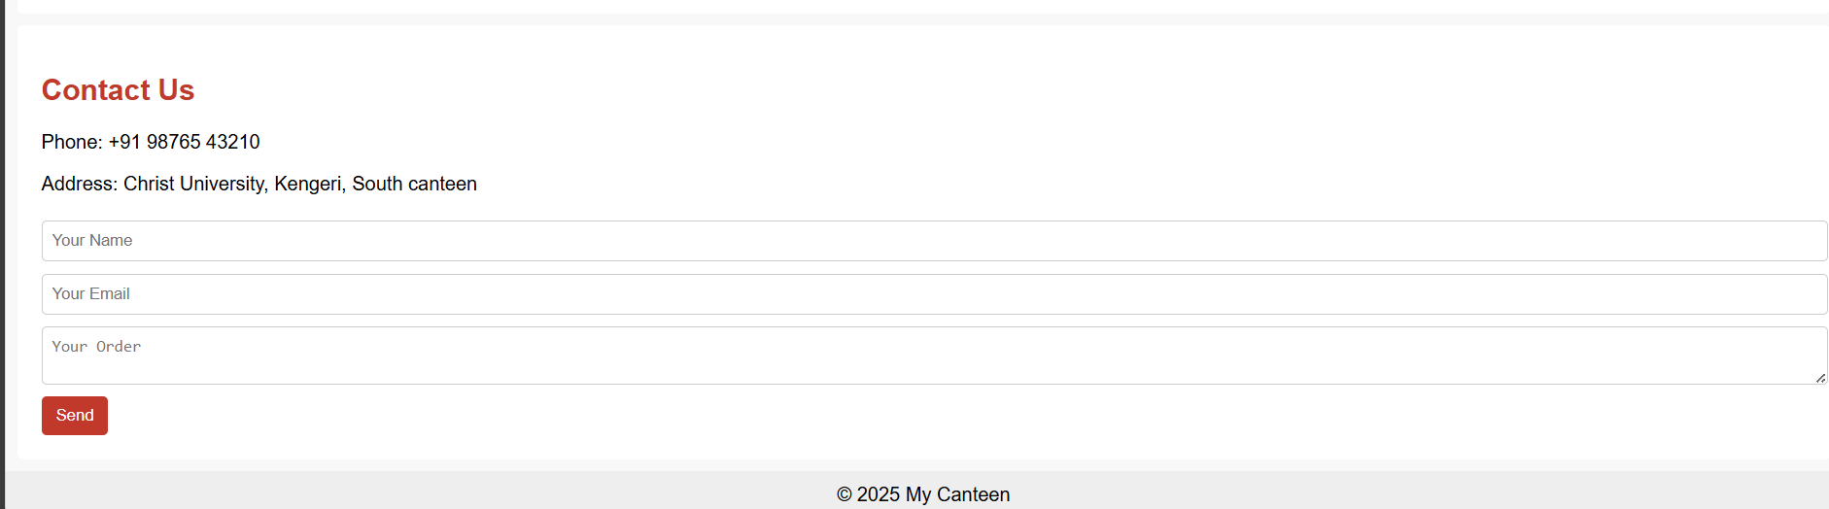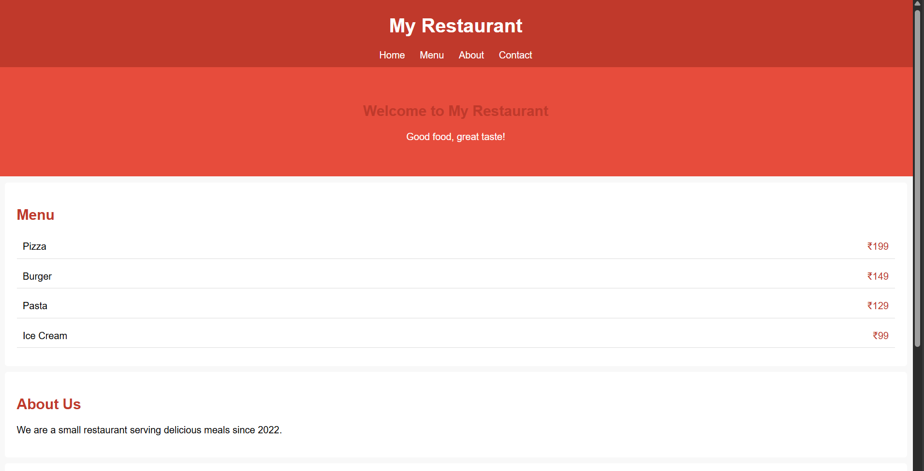

Group Member Details:

Name and Roll Number : Angel Shiju [2462538] , Tenzin Choeying [2462534] , Sai Arjun N [2462528]

Email: [angel.shiju@btech.christuniversity.in , tenzin.choeying@btech.christuniversity.in](mailto:angel.shiju@btech.christuniversity.in%20,%20tenzin.choeying@btech.christuniversity.in) , sai.arjun@btech.christuniversity.in

Course: Front End UI/UX ,3 BTCS IOT

Instructor Name: Dhiraj

Institution: Christ University

Date of Submission: 11-08-2025